Arts Council of Southwestern Indiana
Commission for new Public Media Headquarters
Outdoor Public Art
Call to Artists Requests for Proposals (RFP)

Deadline for Submissions
February 23, 2018 at 4:00 p.m. CST. Email submissions only.

Program Specifics
The Arts Council of Southwestern Indiana is seeking an artist or team of artists to create a public art piece to serve as a gateway to Downtown Evansville, housed on the entry plaza of WNIN Public Media’s new headquarters, located at Riverside Drive and Main Street.

The 2016 Downtown Master Plan Update suggested four Transformational Ideas, two of which meet at this project area: “Riverfront Enhancements” and “An Active Main Street.” The project’s location at WNIN’s headquarters on Main would help draw activity from the riverfront to the traditional Main Street shopping and dining area (which begins at Main and 2nd) and from the Main Street shopping and dining area to the center of the riverfront (Riverside at Main). The link created by the piece will join other future pieces in this two-block long section of Main.

Eligibility Requirements
- Be 18 years of age or older
- Work as a professional artist or part of an art/design team
- Have previously created public art, large-scale works, or outdoor projects
- Carry personal liability insurance for the on site duration of the project
- Be willing to meet all contractual obligations and adhere to a strict deadline

Selection Process
The Arts Council of Southwestern Indiana will create a committee that will review artists’ proposals and award the commission.

Selection Criteria
The selected artist will be chosen based upon the following criteria:
- Work of the highest caliber and effective execution
- Experience of working within Program Specifics and Selection Criteria
- Ability to complete work within a specified timeframe and budget
- Visual impact of the proposed sculpture on pedestrian and vehicular traffic
- Representation of an artistic vision that acknowledges and embodies the current climate in contemporary public art and embraces a broader social consciousness about the community
- Presentation of an artistic vision that displays an awareness of the role of public media
- Appropriateness of content (should be appropriate for all audiences)
Budget
The budget for this artwork will be $25,000. The artist is expected to budget all costs associated with the development and installation of the artwork. This includes supplies, shipping, travel, lodging, equipment, etc. Supplies specific to the artist’s technique or process should be included in artist’s budget.

Sculpture Location & Size

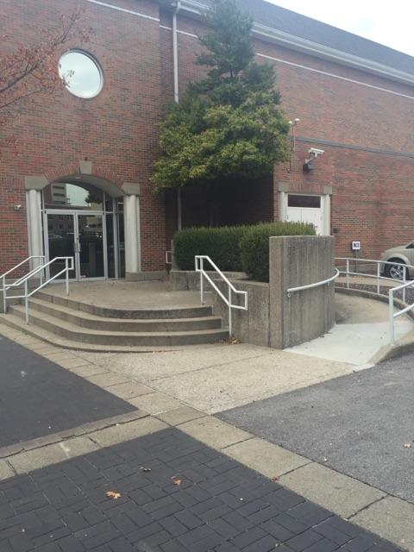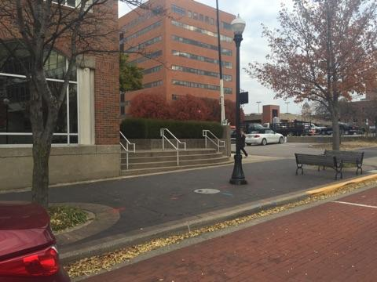
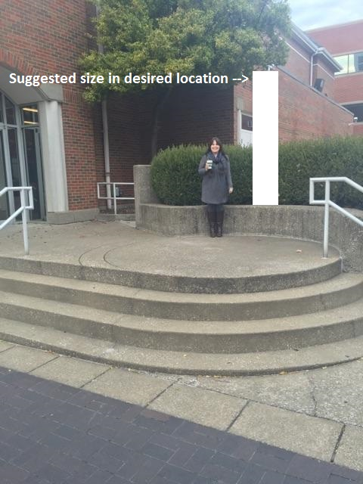

Sculpture will be placed on the east side of the new WNIN Public Media Center, freestanding on the entry plaza. Size of the sculpture is to be determined by the artist but must be visible from Main Street.

Project Timeline
The project will follow this timeline:
- February 23, 2018, 4 p.m. (CDT) Request for Proposals Deadline
- Early March 2018, selection committee reviews proposals
- Mid March 2018, artists are notified of selection.
- June 2018, artwork is delivered and installed

Submission Process
Artists must submit the following information on via email.

- Applicant Information: Complete the form on the last page of this RFP
- Statement of Proposal: This letter should be no longer than one typed letter-sized page using 12-point font and 1 inch margins on all sides. Briefly outline key concepts related to Program Specifics and/or materials you will incorporate into the sculpture.
- Professional Resume or CV: No longer than 4 pages
- General Budget: Include a budget outlining all costs involved with the creation & installation of the sculpture including budget for contractors and/or equipment.
- Proposal Images: (Digital images – up to 5 images)

Include copies of muse, sketches, or examples of related or proposed artwork
- Jpeg or pdf files ONLY
- Good quality, no smaller than 72 dpi
- No larger than 2 MB each
- No hard copies, electronic files only

Digital mock-ups of artwork. If you are unable to create a mock-up digitally, you may scan your drawings to jpeg or pdf format.

Name your digital files according to the following format: LastName_Concept_01.jpg, LastName_Concept_02.jpg, etc.

- Previous Work Sample List and Images: (up to 5 images)
Submit examples of artwork that best represents your experience, style, and ability. You may also submit images of any other work (large scale or otherwise) that best represents your work of the past 5 years. Include a list of work samples
and as much information about each of the samples as possible (include name/title of piece, location, medium, process, dimensions, year completed, and any other pertinent information). Here is an example of a Work Sample entry:

- Flowers of the Lake, 234 N. Main St., Evansville, bronze, 1’ x 2’ x 3’, 2014, JavierArtist_01.jpg

Previous Work Images (up to 5 images, same considerations as the proposal images)

Name your submitted digital files according to the following format: FirstLast_01.jpg, FirstLast_02.jpg, etc.

Delivery of Submissions
Each artist must submit via email, with subject line “WNIN PUBLIC ART SUBMISSIONS.” All submissions must be received by 4:00pm (CDT) on February 2, 2018.

Submissions MUST be emailed to:
Andrea Adams andrea.adams@artswin.org
Call (812) 422-2111 with any questions.

The Arts Council of Southwestern Indiana
New Public Media Headquarters outdoor public art
Request for Proposal Form

Applicant Information

Artist Name:

Mailing Address:

City/State/Zip:

Day Phone:

Email:

Website:

How did you hear about this RFP?

