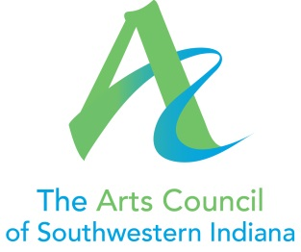

Position Title: Director of Communications and Community Projects
Supervisor: Executive Director
Hours: 40 hours/week, to include some evenings and weekends
Purpose: The Director of Communications and Community Projects coordinates and manages all communications activities of the Arts Council of Southwestern Indiana, as well as ongoing and new community projects. A new position in the organization, the Director will work with the Executive Director and Gallery Director to educate and engage artists, donors, and the community at large.

Essential Functions:
- Develop materials for soliciting funds through existing Arts Council development programs, including but not limited to:
  - Annual Campaign
  - Corporate Campaign
  - Membership Campaign

- Develop informational and sponsorship materials for programs and special events, including but not limited to:
  - Gallery Exhibits
  - Brown Bag Series
  - Film Festival
  - Classics by Candlelight
  - Civic Theater Underground Series
  - The Arts Awards

- Effectively use social media, email, direct mail, and other communication channels to engage the broader community, developing donors, volunteers, and sponsors.

- Work with the Executive Director, Executive Committee, and Marketing Committee to set communications and marketing goals.

- Manage the Arts Council’s work on community projects including but not limited to:
  - First Fridays in Haynie’s Corner
  - Parksfest

- Work with Executive Director to manage Arts Council grant applications and grant reporting.

- Maintain regular and meaningful communication with donors, including donor solicitation and appreciation.

- Schedule publicity for projects and programs (including television and radio interviews) occasionally speaking on behalf of the organization when Executive Director is unavailable.

- Create and distribute press releases, and otherwise work with media contacts to promote the organization.

- Perform other duties as assigned by the Executive Director.

Experience
The ideal candidate will have excellent verbal and written communication skills, an understanding of appropriate voice for digital media (Facebook, Twitter, etc.) versus traditional media, and ability to thrive in a non-profit environment. The position must be filled by an individual eager to attend arts and cultural events in the community, serving as an ambassador for the organization.
The ideal candidate will have 3+ years’ experience in communications and community engagement or related field, be proficient in Word and Excel, with graphic design experience preferred.
Salary Range: $32,000 to $37,000

Please submit resume and references to anne.mckim@artswin.org
Applications will be reviewed as received. The position will remain posted until filled.

