**Arts Council of Southwestern Indiana**

*Commission for The Arts Council of Southwestern Indiana Rooftop Art Deck Functional Sculptural Outdoor Furniture*

Request for Proposals (RFP)

**Deadline for Submissions**

February 21, 2019 at 4:00 p.m. CST. Email submissions only.

**Program Specifics**

The Arts Council of Southwestern Indiana is seeking an artist or team of artists to create furniture for the new 212 Main Street *Rooftop Art Deck*, to be opened in spring of 2019. The ideal proposal(s) will use weather proof materials to create seating and tables to be permanently located on the *Art Deck.* Furniture must be functional sculpture or artistically designed, and must have a guaranteed lifespan of at least ten (10) years.

The *Art Deck* will be used for outdoor events, receptions, concerts, and other performances and gatherings, and will be open to the public during Arts Council business hours.

**Eligible Applicants will:**

* Be 18 years of age or older
* Work as a professional artist, part of an art/design team, carpenter, welder, or other professional craftsperson
* Have previously created public art, large-scale works, or outdoor, construction, or furniture projects
* Carry personal liability insurance for the on-site duration of the project
* Be willing to meet all contractual obligations and adhere to a strict deadline

**Selection Process**

The Arts Council of Southwestern Indiana will create a committee that will review artists’ proposals and award the commission.

**Selection Criteria**

*The selected artist will be chosen based upon the following criteria:*

* Work of the highest caliber and effective execution
* Experience of working within *Program Specifics and Selection Criteria*
* Ability to complete work within a specified timeframe and budget
* Visual impact of the proposed sculptural furniture
* Representation of an artistic vision that acknowledges and embodies the current climate in contemporary public art and embraces a broader social consciousness about the community
* Presentation of an artistic vision that displays an awareness of the *Art Deck* as a curated public space
* Appropriateness of content (should be appropriate for all audiences)

**Budget**

Total Budget: $30,000

Proposals may be submitted for multiple elements totaling the entire budget, or for individual elements totaling a percentage of the budget. (For example, a proposal may be for a bench (or other element) totaling $10,000, or a proposal may be for all elements totaling $30,000.) The artist(s) is expected to budget all costs associated with the development and installation of the artwork. This includes supplies, shipping, travel, lodging, equipment, etc. Supplies specific to the artist’s technique or process should be included in artist’s budget.

**Sculpture Location & Size** (larger images available upon request or at <https://www.artswin.org/gallery_calls_2018>)



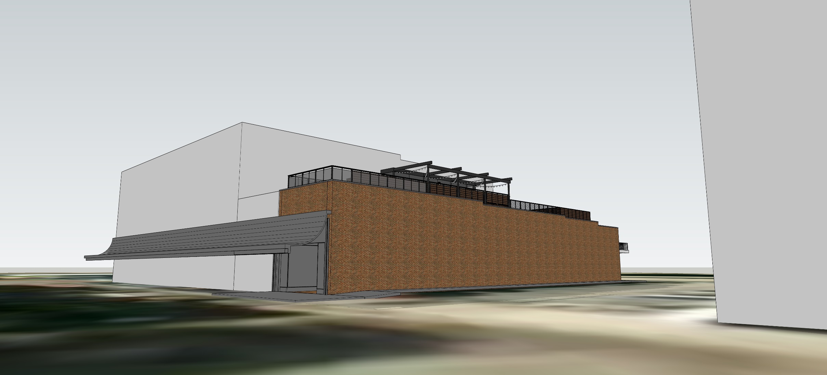

Furniture will be placed on the rooftop of the Arts Council of Southwestern Indiana gallery, located at 212 Main Street. Size of the sculptural furniture pieces is to be determined by the artist(s). Some elements may be visible to pedestrians on Main Street, depending on placement and size.

**Project Timeline**

*The project will follow this timeline:*

* February 21, 2019, 4 p.m. (CDT) Request for Proposals Deadline
* February 28, 2019, selection committee reviews proposals
* March 1, 2019, artists are notified of selection.
* May 2019, artwork is delivered and installed

**Submission Process**

Artists must submit the following information on **via email.**

* **Applicant Information**: Complete the form on the last page of this RFP
* **Statement of Proposal:** This letter should be no longer than one typed letter-sized page using 12-point font and 1 inch margins on all sides. Briefly outline key concepts related to Program Specifics and/or materials you will incorporate into the sculpture.
* **Professional Resume or CV:** No longer than 4 pages
* **General Budget:** Include an itemized budget outlining all costs involved with the creation & installation of the sculpture including budget for contractors and/or equipment.
* **Proposal Images:** (Digital images – up to 5 images)

*Include copies of muse, sketches, or examples of related or proposed artwork*

* Jpeg or pdf files ONLY
* Good quality, no smaller than 72 dpi
* No larger than 2 MB each
* No hard copies, electronic files only

Digital mock-ups of artwork. If you are unable to create a mock-up digitally, you may scan your drawings to jpeg or pdf format.

Name your digital files according to the following format: LastName_Concept_01.jpg, LastName_Concept_02.jpg, etc.

* **Previous Work Sample List and Images:** (up to 5 images)

Submit examples of artwork that best represents your experience, style, and ability. You may also submit images of any other work (large scale or otherwise) that best represents your work of the past 5 years. Include a list of work samples

and as much information about each of the samples as possible (include name/title of piece, location, medium, process, dimensions, year completed, and any other pertinent information). Here is an example of a Work Sample entry:

1. *Flowers of the Lake*, 234 N. Main St., Evansville, bronze, 1’ x 2’ x 3’, 2014, JavierArtist_01.jpg

Previous Work Images (up to 5 images, same considerations as the proposal images)

Name your submitted digital files according to the following format: FirstLast_01.jpg, FirstLast_02.jpg, etc.

**Delivery of Submissions**

Each artist must submit via email, with subject line “212 MAIN SCULPTURE PROJECT.” All submissions must be received by **4:00pm (CDT) on February 21, 2019.**

**Submissions MUST be emailed to:**

Andrea Adams [andrea.adams@artswin.org](mailto:andrea.adams@artswin.org)

Call (812) 205-0927 with any questions.

The Arts Council of Southwestern Indiana

*ART DECK SCULPTURAL FURNITURE PROJECT*

Request for Proposal Form

Applicant Information

Artist Name:

Mailing Address:

City/State/Zip:

Day Phone:

Email:

Website:

How did you hear about this RFP?