DOWNTOWN EVANSVILLE – Economic Improvement District
Commission for graphic design and photography
Call to Artists Requests for Proposals (RFP)

Deadline for Submissions
Thursday, February 28 at 4:00 p.m. CST. Email submissions only.

Program Specifics
DOWNTOWN EVANSVILLE – Economic Improvement District (EID) is seeking several artists to submit graphic artwork or photography for designs to be printed on vinyl wrapping that will be attached to the fence surrounding the park at Fourth and Main Streets. The height of the fence wrap will be 6 feet, and the width of each design will be 3 feet to 8 feet per the respondent’s design. By submitting a proposal, artists agree that their photography or design will belong to the EID for a period of up to 2 years.

Please be aware that the work may be printed on mesh or solid vinyl, depending on overall wind load. The mesh results in a lowered vibrancy of the finished image. Also, your work will have grommets inserted to attach it to the fence. These grommets will be a few inches from the top and bottom edge, and will be located approximately every 24 inches.

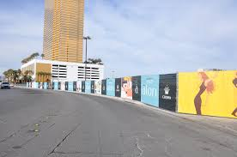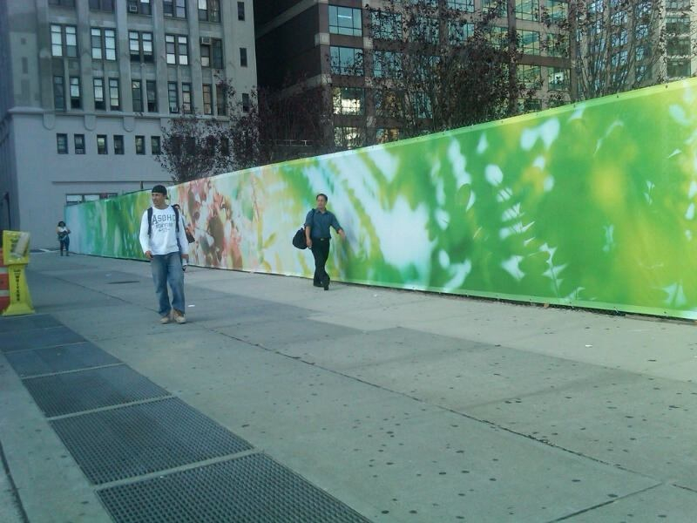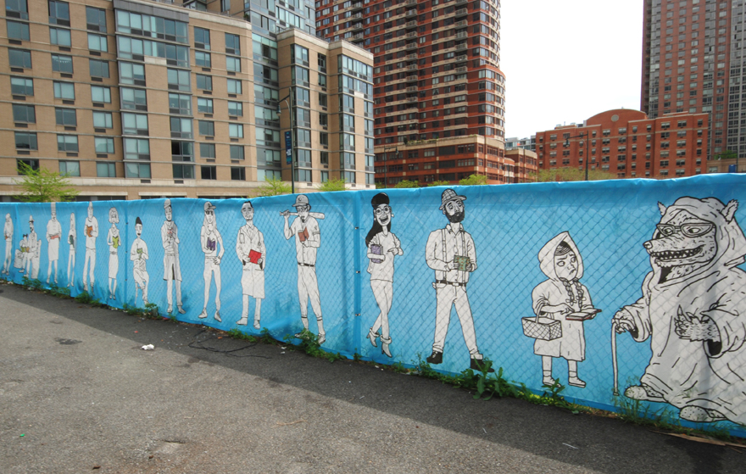
Examples from other communities.

Branding Statement of the EID
In partnership with the Downtown Evansville Economic Improvement District (EID), Gray Loon was commissioned to define the brand for Downtown Evansville, Indiana. The process included discovery sessions with multiple key groups including civic leaders, business owners, visitors, and residents.

A brand was developed that embraces Evansville's rich history but also captures the vitality, energy, passion and strong economic growth:

“This new brand embodies 200 years of hopes and aspirations, love and death, old buildings and new, progress and retrenchment. Through all of that, strangers were welcomed into shops and restaurants, couples met and married, babies were born and funerals were held, people met at the train and bus terminals, businesses opened, and fortunes were made and lost.

It imparts the concept that you are going to run into someone you know on Main Street, that hawks grace the skyline as they soar in our Downtown and the streets run at a 45-degree angle to the rest of the world. All while we are nestled quietly against the oxbow of the Ohio River since 1812.

This is the story of place condensed down to not just a logo but our collection of businesses, homes, churches and civic spaces: a neighborhood, a place—which confidently acknowledges the past, but also embraces the future.”

Selection Process
The Selection Committee will review the submissions, and chose up to 6 artists who will be asked to participate in the project. Chosen designs will become the property of DOWNTOWN EVANSVILLE for a period of up to 2 years. Each artist will be given a $250 award for the use of the image/design.

Selection Criteria
The selected artist will be chosen based upon the following criteria:
- Work of the highest caliber and effective execution
- Experience of working within Program Specifics and Selection Criteria
- Visual impact of the proposed imagery on pedestrian and vehicular traffic
- Representation of an artistic vision that acknowledges and embodies the current climate in contemporary public art and embraces a broader social consciousness about the community
- Presentation of an artistic vision that displays an awareness of the branding of the EID
- Appropriateness of content (should be appropriate for all audiences)
- The design should not include the DOWNTOWN EVANSVILLE logo, but the selection committee will be instructed to keep the branding statement in mind when reviewing submissions
- By submitting a proposal, artists agree that their photography or design will belong to the EID for a period of up to 2 years

Award
Each chosen artist will be granted a $250 award. Up to 6 artists will be chosen.

Fence Location and Size
The chosen designs will be printed on vinyl wrapping attached to chain link fencing surrounding the park at Fourth and Main Streets. The height will be 6 feet, and the width will be from 3 feet to 8 feet, per the respondent’s design.

Other Information
The email you received also contained the EID’s Brand Manual. Please refer to it for the EID’s preferred color palate, logo and variations, and typography. Again, the EID is not seeking a new logo, or an extension of its logotype, but rather additional story telling related to its brand.

Project Timeline
The project will follow this timeline:
- February 28, 2019 at 4PM
- Week of March 4, 2019
- Week of March 11, 2019
- Week of March 18, 2019
- Week of April 1, 2019

Submission Process
Artists must submit the following information on via email.

- Applicant Information: Complete the form on the last page of this RFP
- Proposal Images: All images and graphic designs should be hi-resolution
- Production Specification: Final image must be ready to print in either Vector or PSD format, with a minimum of 300 DPI.

Delivery of Submissions
Each artist must submit via email, with subject line “FOURTH AND MAIN FENCE PROJECT”. All submissions must be received by 4:00pm (CDT) Thursday, February 28, 2019.

Submissions MUST be emailed to:
Andrea Adams andrea.adams@artswin.org
Call (812) 422-2111 with any questions.

DOWNTOWN EVANSVILLE EID
Commission for graphic design and photography
Request for Proposal Form

Applicant Information

Artist Name:

Mailing Address:

City/State/Zip:

Day Phone:

Email:

Website:

How did you hear about this RFP?

