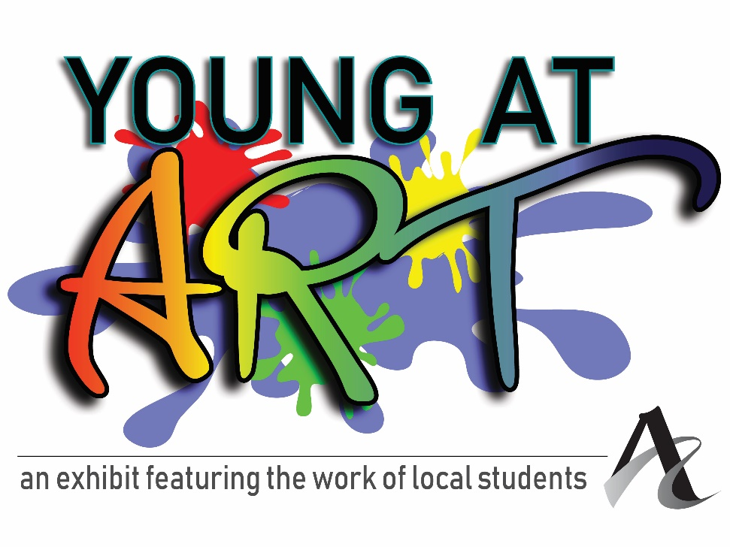
Exhibit dates:
March 11 – 26

Closing Reception:
Saturday, March 23
12 – 2 p.m.

Open to all students in grades:
Kindergarten – 8th

Drop artwork off at:
212 Main
Evansville, IN
Feb. 25 - March 1
10 a.m. – 4 p.m.

Pick artwork up on:
March 27, 28, & 29
10 a.m. – 4 p.m.

One 2D piece or one 3D piece per young artist.

Teachers:
Submit up to ten 2D pieces and/or ten 3D pieces per school

If teachers need assistance transporting artwork to and from downtown, please contact Andrea Adams at andrea.adams@artswin.org

Please fill out the below information to be handed in at time of drop off.
Teachers may send in their own sheet with the relevant information.

Student’s Name: ____________________________________________________________

Title of Artwork: ______________________________________________________________

Medium: ____________________________________________________________________

School (or “Homeschooled”): ________________________________________________

Grade: _____________________

Parent or teacher’s email address: ___________________________________________

Parent or teacher’s phone number: __________________________________________

Important: All work should be clearly labeled with the student’s name on the piece. Work that is unmatted or unframed may be pinned in the four corners or adhesive may be used on the back of the piece, which may result in permanent marks on the corners or the back of the piece.

If your student would like to sell their work in this exhibit, they may add a price. The Arts Council takes a 35% commission on all sales, which goes right back into our programming. There is a process for artists getting their share of sales, which usually takes about 3-4 weeks.

Price, if for sale: ________________

If the piece sells, to whom should the check be made out?

______________________________________________________

• Hold Harmless Agreement: Submission of this application and the piece(s) represented, shall constitute an agreement on the part of the artist to comply with the conditions set forth in this prospectus, including the following: I hereby release and discharge The Arts Council of Southwestern Indiana staff and board from any and all claims occasioned by damage or loss of art while in the possession of The Arts Council of Southwestern Indiana. No work accepted for the exhibition may be withdrawn prior to the close of the exhibition. Permission to reproduce the work for publicity, documentary or educational purposes is hereby granted.

Parent Signature Date

