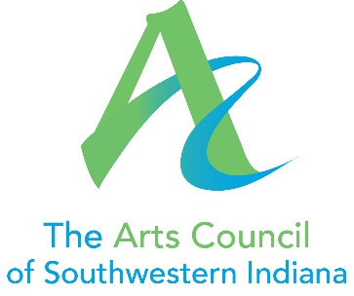
Why You Are/Who You Are/Where You Are
A Community Photography Project Presented by
the Arts Council of Southwestern Indiana,
with a public reception sponsored by Banterra Bank
The Arts Council of Southwestern Indiana wants to tell your story through images of the people, places, memories and things that you love.
The community is invited to contribute to a fall 2019 art installation by sharing personal photographs for display in the Bower-Suhrheinrich Foundation Gallery. To participate, individuals will submit 5 photos, one for each of the following categories:
- A person you love
- An object you love
- A place you love
- An important memory
- A photo of yourself

- Participants do not need to be artists, and there are no age or eligibility requirements to enter the exhibit.
- Images may be new or old, but must be printed on photo paper (historic photographs may be submitted on original material)
- Images may not exceed 8.5 inches by 11 inches in size, and may be smaller
- All photos must be labeled on the back with the submitter’s name, phone number, and email address.
- Photos must be delivered in a large (e.g. manila) envelope labeled with submitter’s name, phone number, and email address. THIS IS TO ENSURE THE SAFETY OF YOUR PHOTOS DURING DROP OFF AND PICK UP.
- The Arts Council retains the right to reject photos from the exhibit deemed offensive or inappropriate. Inclusion in the project is at the discretion of the Arts Council staff and Board of Directors.
Sept. 10 - 14, 12:00 pm to 2:00 pm _______Drop off images at the Arts Council of Southwestern Indiana (212 Main Street, Evansville, IN 47708)
Oct. 11 & 12, 12:00 pm to 2:00 pm _______Pick up images at the Arts Council of Southwestern Indiana (212 Main Street, Evansville, IN 47708)
September 27, 5:30 pm to 7:00 pm _______Public exhibit reception at the Arts Council of Southwestern Indiana (212 Main Street, Evansville, IN 47708), sponsored by Banterra Bank.

