ONB Mural project
Old National Bank
The Arts Council of Southwestern Indiana
Call to Artists Requests for Proposals (RFP)

Deadline for Submission
January 12, 2021 at 4:00 p.m. CST. Email submissions only.

Program Specifics
The mission of this project is to create a sense of excitement and civic pride in downtown Evansville by introducing new art projects on the exterior of Old National Bank buildings.

Eligibility Requirements
Selected artist(s) must:
- Be 18 years of age or older
- Work as a professional artist or part of an art/design team
- Have previously created public art, large-scale works, or outdoor projects
- Carry personal liability insurance for the on-site duration of the project
- Be willing to meet all contractual obligations and adhere to a strict deadline
- Live or work within 400 miles of Evansville, Indiana.

Selection Process
A committee composed of Old National representatives and arts professionals will review artists’ proposals and award commissions. Selected artists will work with organizers to further develop designs to fit designated mural sites. The committee reserves the right to reject all submittals. Old National Bank reserves the right to commission a mural for only one of the proposed sites.

Selection Criteria
The selected artist will be chosen based upon the following criteria:
- Work of the highest caliber and effective execution
- Experience of working within Program Specifics and Selection Criteria
- Ability to complete work within the specified timeframe and budget
- Visual impact of the proposed sculpture on pedestrian and vehicular traffic
- Representation of an artistic vision that acknowledges and embodies the current climate in contemporary public art
- Submissions will not specifically reference Old National Bank, but shall keep in mind the high standards and community involvement that Old National Bank strives to maintain.
- Appropriateness of content (should be appropriate for all audiences)

Budget
- $20-40/ square foot
- Materials and labor should be included
- Please specify size of project on renderings

The artist is expected to budget all costs associated with the development and installation of the artwork. This includes supplies, shipping, travel, lodging, equipment, etc. Supplies specific to the artist’s technique or process should be included in artist’s budget.

Mural Location & Size
Option 1: “ONSD” at 101 NW 4th Street. Mural will cover a large percentage of the painted brick wall facing the 5th Street City Parking Garage. ONB will consider options that include painting the entire wall a new base color, and will consider artwork that encompasses some or all of the windows on that side.
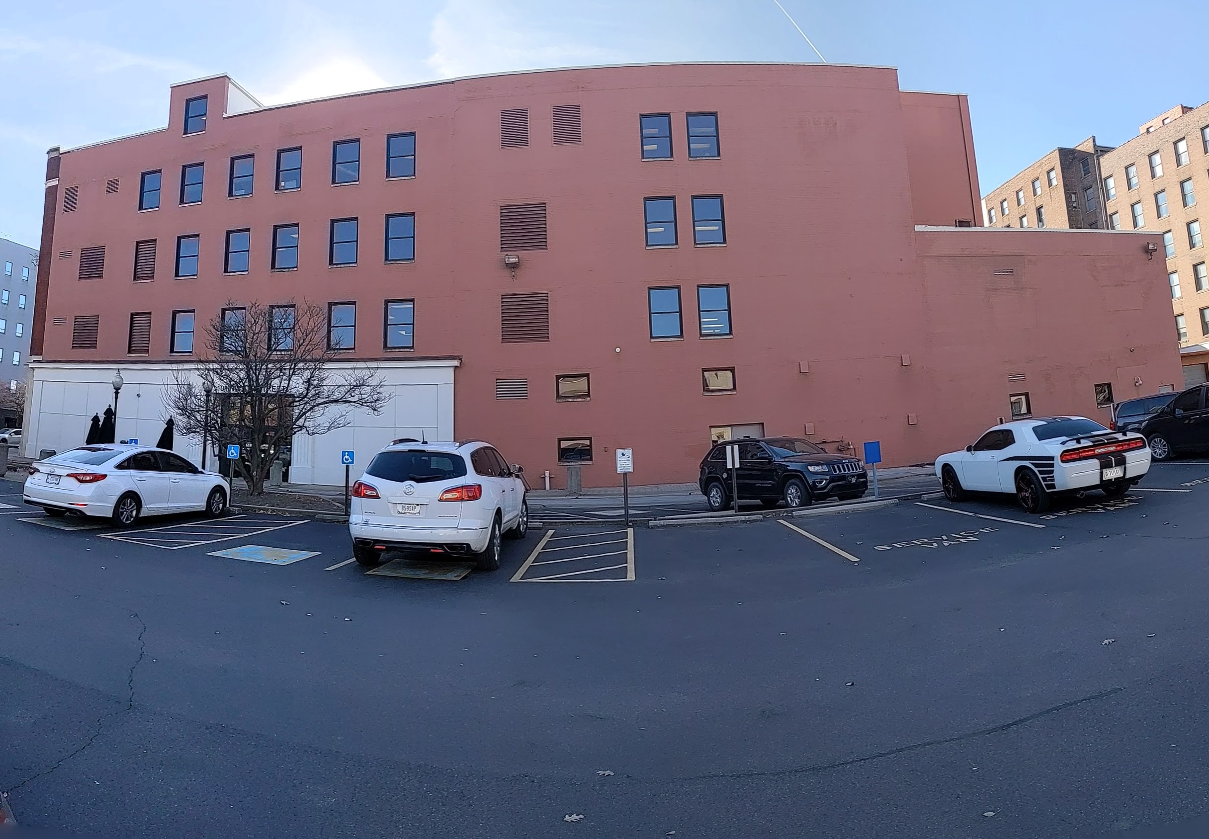
Option 2: “ONB Hub” at 123 Main Street. Mural will wrap around the corner of the building, and could be as tall as all 3 floors, no wider than 15 feet in either direction.
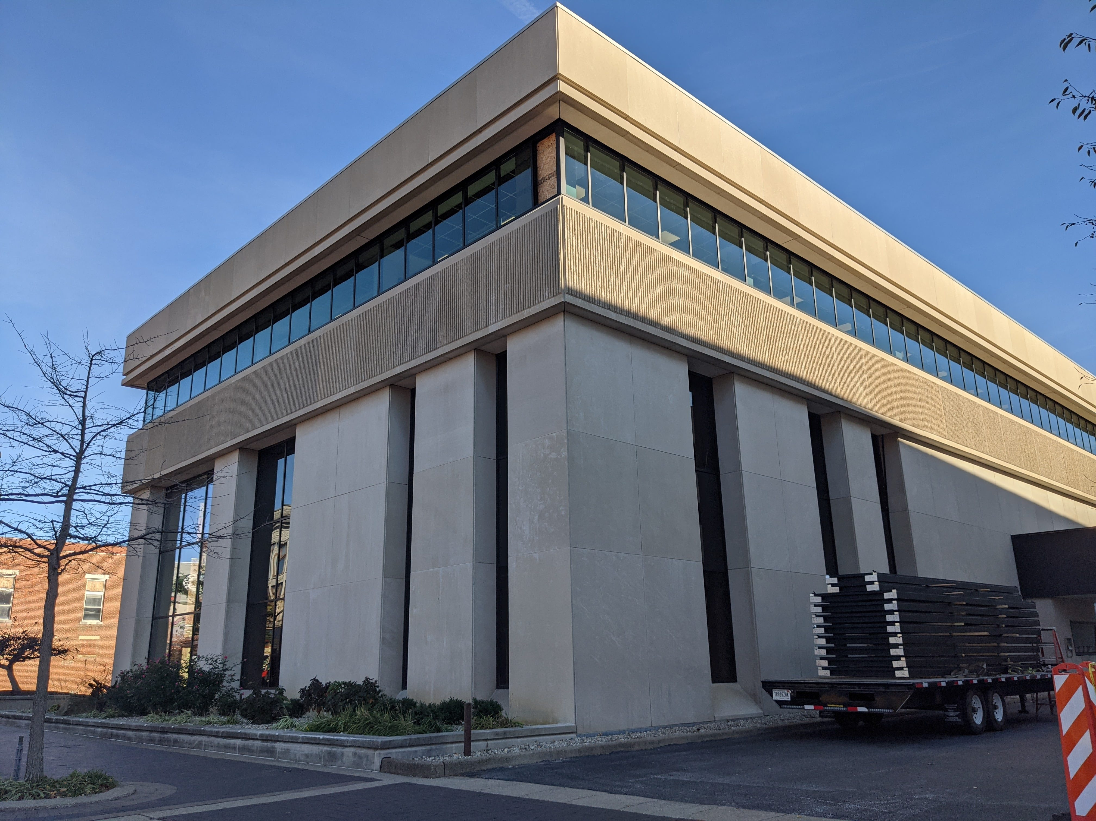
Project Timeline
The project will follow this timeline:

- January 12, 2021, by 4 p.m. (CDT) Request for Proposals Deadline
- January 26, 2021, selection committee reviews proposals
- January 29, 2021, artists are notified of selection.
- Artwork installed by April 30
- Ribbon cutting TBD

Submission Process
Artists must submit the following information via email.

- Applicant Information: Complete the form on the last page of this RFP
- Statement of Proposal: This letter should be no longer than one typed letter-sized page using 12-point font and 1 inch margins on all sides. Briefly outline key concepts related to Program Specifics and/or materials you will incorporate into the sculpture.
- Professional Resume or CV: No longer than 4 pages
- General Budget: Include a budget outlining all costs involved with the creation & installation of the sculpture including budget for contractors and/or equipment.
- Proposal Images: (Digital images – up to 5 images)
Include copies of muse, sketches, or examples of related or proposed artwork
- Jpeg or pdf files ONLY
- Good quality, no smaller than 72 dpi
- No larger than 2 MB each
- No hard copies, electronic files only
- Digital mock-ups of artwork. If you are unable to create a mock-up digitally, you may scan your drawings to jpeg or pdf format.
    - Name your digital files according to the following format: LastName_Concept_01.jpg, LastName_Concept_02.jpg, etc.

- Previous Work Sample List and Images: (up to 5 images)
Submit examples of artwork that best represents your experience, style, and ability. You may also submit images of any other work (large scale or otherwise) that best represents your work of the past 5 years. Include a list of work samples
and as much information about each of the samples as possible (include name/title of piece, location, medium, process, dimensions, year completed, and any other pertinent information). Here is an example of a Work Sample entry:

- Flowers of the Lake, 234 N. Main St., Evansville, bronze, 1’ x 2’ x 3’, 2014, JavierArtist_01.jpg
Previous Work Images (up to 5 images, same considerations as the proposal images)

Name your submitted digital files according to the following format: FirstLast_01.jpg, FirstLast_02.jpg, etc.

Delivery of Submissions
Each artist must submit via email, with subject line “ONB Mural project”. All submissions must be received by 4:00pm (CDT) on January 12, 2021.

Submissions MUST be emailed to:
Andrea Adams andrea.adams@artswin.org
Copied to Cory Mills cory.mills@oldnational.com

Call (812) 303-3178 or email andrea.adams@artswin.org with any questions.

For more information about Old National Bank please visit https://www.oldnational.com/about/our-company/the-onb-way.

For reference, please review the Old National Bank Color Palette:

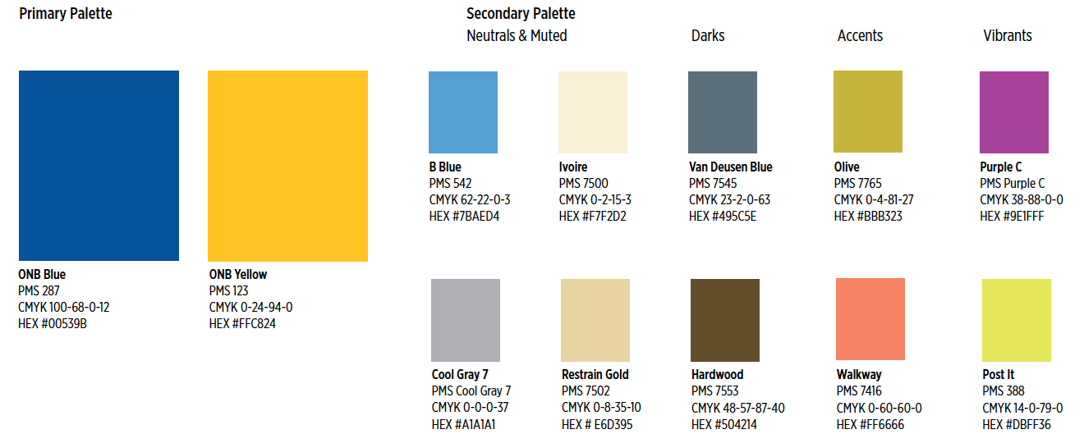

ONB mural project
Request for Proposal Form

Applicant Information

Artist Name:

Mailing Address:

City/State/Zip:

Day Phone:

Email:

Website:

How did you hear about this RFP?

