Gas Meter Painting Project
The Downtown Evansville Economic Improvement District (EID)
The Arts Council of Southwestern Indiana
Call to Artists Requests for Proposals (RFP)

Deadline for Submission
February 26, 2021 at 4:00 p.m. CST. Email submissions only.

Program Specifics
The mission of this project is to create a sense of excitement and civic pride in downtown Evansville by introducing new art projects which will incorporate selected gas meters and piping (not any nearby electrical panels). The EID is looking for a playful, whimsical, joy-filled way to decorate these needed infrastructure items.

Eligibility Requirements
Selected artist(s) must:
- Be 18 years of age or older
- Work as a professional artist or part of an art/design team
- Carry personal liability insurance for the on-site duration of the project
- Be willing to meet all contractual obligations and adhere to a strict deadline
- Live or work within 100 miles of Evansville, Indiana.

Selection Process
A committee composed of adjoining property owners, Downtown Evansville EID staff and board, arts professionals, and a representative of CenterPoint Energy will review artists’ proposals and award commissions. Selected artists will work with organizers to further develop designs to fit designated mural sites. The committee reserves the right to reject all submittals. See Project Locations and Scope for more information.

Selection Criteria
The selected artist will be chosen based upon the following criteria:
- Work of the highest caliber and effective execution
- Experience of working within Program Specifics and Selection Criteria
- Ability to complete work within the specified timeframe and budget
- Visibility to pedestrians and vehicular traffic
- Representation of an artistic vision that acknowledges and embodies the current climate in contemporary public art
- Appropriateness of content (should be appropriate for all audiences)
- Longevity of items used in project
- Value relative to project goals

Budget
- $2,500-4,000 for meters and piping
  - Subordinate murals where indicated will have a budget of $15-35 per square foot inclusive of materials
- Materials and labor should be included
- Please specify locations on renderings

The artist is expected to budget all costs associated with the development and installation of the artwork. This includes supplies, shipping, travel, lodging, equipment, etc. Supplies specific to the artist’s technique or process should be included in artist’s budget.

Technical Information about Meters
The completed work should include the meter box (CenterPoint Energy property) in red outline; may include piping, railing, bollards in the yellow outline (Property Owner’s); and may not cover anything shown in a green box. CenterPoint Energy may change any design for engineering concerns. The scope of this project is gas meters and piping only, your proposal should not include any electrical meters or panels.

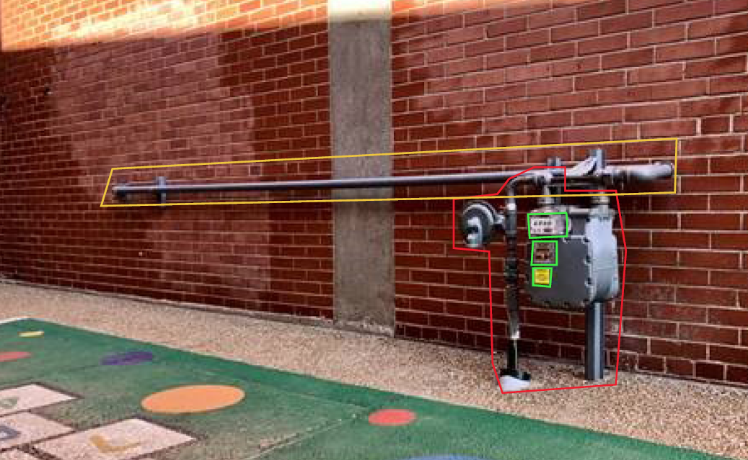

Project Locations and Scope
Game Room Alley (between 4th Street and 3rd Street): Meter and piping on wall in this activated alley. Artist may include a subordinate proposal including mural on wall behind meter and pipe.

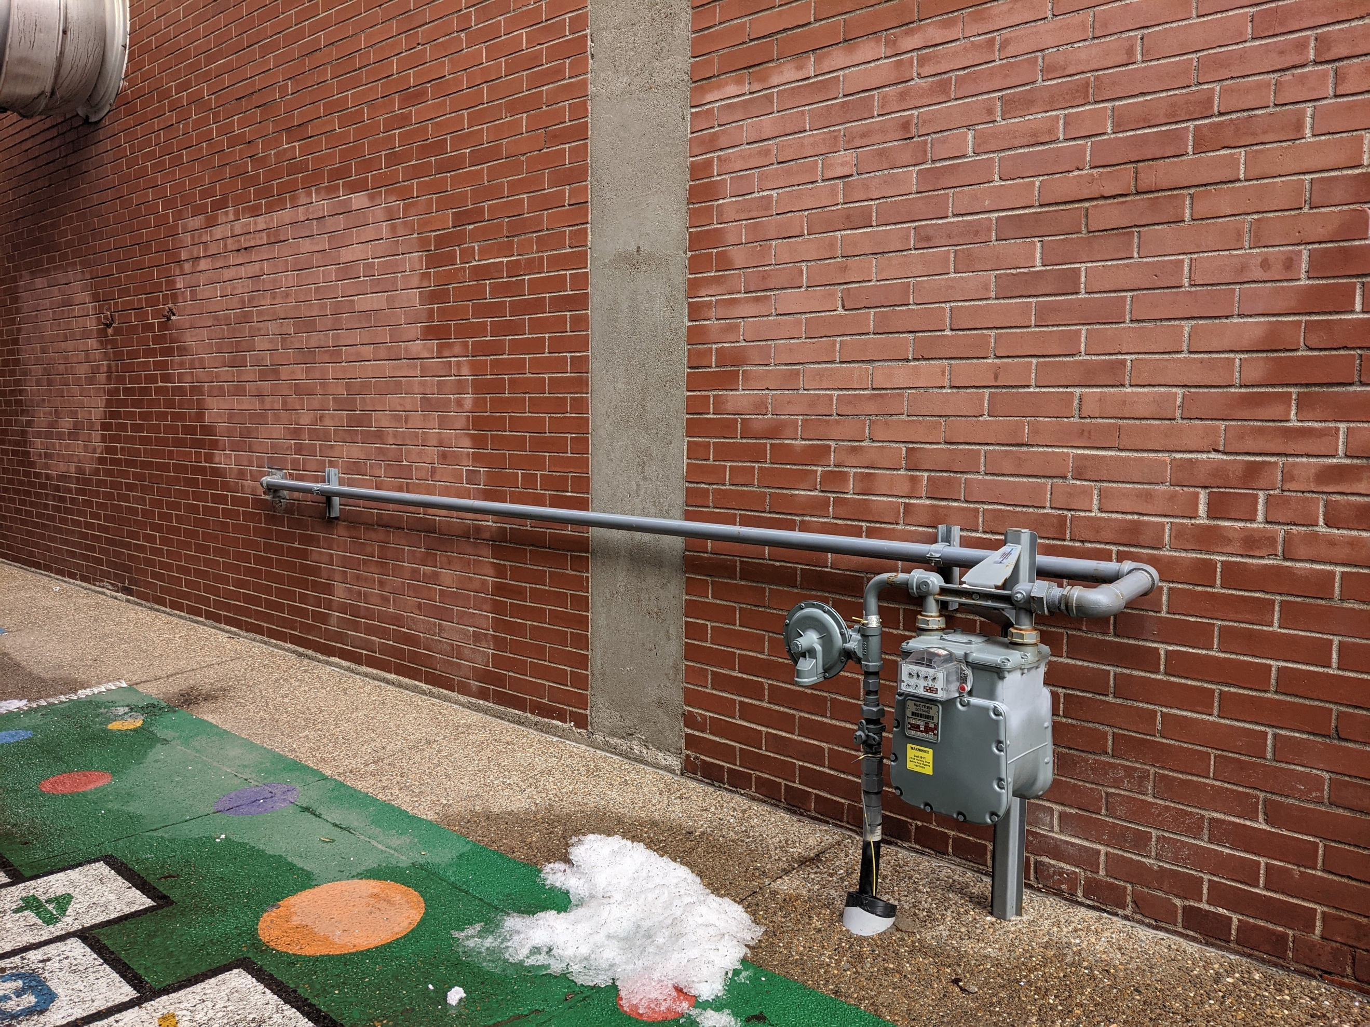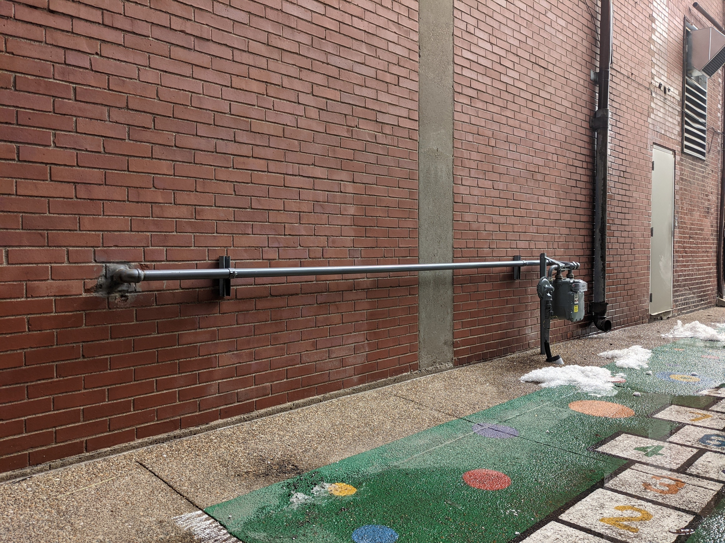

Project Timeline
The project will follow this timeline:

- February 26, 2021, by 4 p.m. (CDT) Request for Proposals Deadline
- March 12, 2021, selection committee reviews proposals
- March 19, 2021, artists are notified of selection.
- Artwork installed by July 1, 2021
- Ribbon cutting TBD

Submission Process
Artists must submit the following information via email.

- Applicant Information: Complete the form on the last page of this RFP
- Statement of Proposal: This letter should be no longer than one typed letter-sized page using 12-point font and 1-inch margins on all sides. Briefly outline key concepts related to Program Specifics and/or materials you will incorporate into the sculpture.
- Professional Resume or CV: No longer than 4 pages
- General Budget: Include a budget outlining all costs involved with the creation & installation of the project

- Proposal Images: (Digital images – up to 5 images)
Include copies of muse, sketches, or examples of related or proposed artwork
- Jpeg or pdf files ONLY
- Good quality, no smaller than 72 dpi
- No larger than 2 MB each
- No hard copies, electronic files only
- Digital mock-ups of artwork. If you are unable to create a mock-up digitally, you may scan your drawings to jpeg or pdf format.
    - Name your digital files according to the following format: LastName_Concept_01.jpg, LastName_Concept_02.jpg, etc.

- Previous Work Sample List and Images: (up to 5 images)
Submit examples of artwork that best represents your experience, style, and ability. You may also submit images of any other work (large scale or otherwise) that best represents your work of the past 5 years. Include a list of work samples
and as much information about each of the samples as possible (include name/title of piece, location, medium, process, dimensions, year completed, and any other pertinent information). Here is an example of a Work Sample entry:

- Flowers of the Lake, 234 N. Main St., Evansville, bronze, 1’ x 2’ x 3’, 2014, JavierArtist_01.jpg
Previous Work Images (up to 5 images, same considerations as the proposal images)

Name your submitted digital files according to the following format: FirstLast_01.jpg, FirstLast_02.jpg, etc.

Delivery of Submissions
Each artist must submit via email, with subject line “Gas Meter Painting Project”. All submissions must be received by 4:00pm (CDT) on February 26, 2021.

Submissions MUST be emailed to:
Andrea Adams andrea.adams@artswin.org
Copied to Josh Armstrong josh@downtownevansville.com

Call (812) 303-3178 or email andrea.adams@artswin.org with any questions.

For more information about the EID, please visit https://www.downtownevansville.com/about_us/index.php

Gas Meter Painting Project
Request for Proposal Form

Applicant Information

Artist Name:

Mailing Address:

City/State/Zip:

Day Phone:

Email:

Website:

How did you hear about this RFP?

