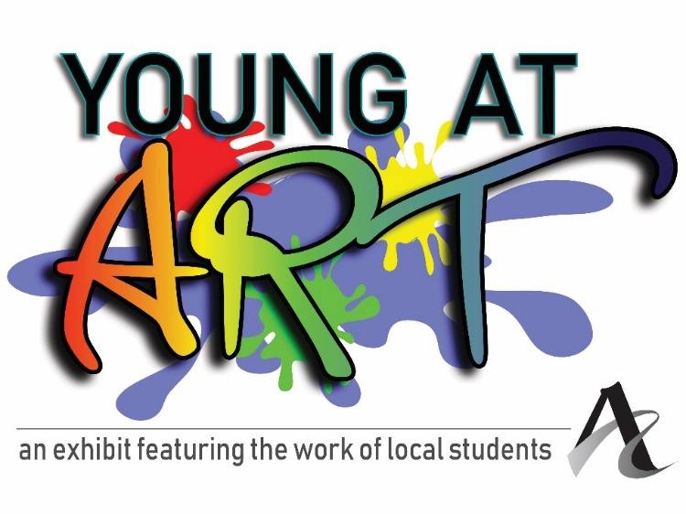
Young at Art, the Arts Council’s annual youth art exhibit, gives local young artists in grades K-8 the opportunity to display artwork in a professional gallery setting.

Each artist (grades K-8th) is allowed one 2D piece, or one 3D piece.
Work can be dropped off at 212 Main Street during the following times:
February 21st – 24th, 10 a.m. – 4 p.m. and February 28th – March 2nd, 10 – 4 p.m.

Teachers can submit up to ten 2D pieces and/or ten 3D pieces per school.
Because the Arts Council wants to make it easy for teachers to enter their students’ work, we are available to pick up artwork from any school in the area on March 6th or March 7th and return on April 6th or 7th. Please email Andrea at andrea.adams@artswin.org to make arrangements.

Calendar:
Exhibit dates:
March 14 – March 31, 2023

Artists Reception:
Saturday, March 18, 2023
Noon – 1:30 p.m.

Open to all students in grades:
Kindergarten – 8th in any school district
Homeschoolers are welcome!

Drop artwork off at:
212 Main
Evansville, IN
February 21st – 24th, 10 a.m. – 4 p.m.
February 28th – March 2nd, 10 – 4 p.m.

Because the Arts Council wants to make it easy for teachers to enter their students’ work, we are available to pick up artwork from any school in the area on February 22nd or 23rd, and return on April 5th or 6th. Please email Andrea at andrea.adams@artswin.org to make arrangements.

Artwork pick up on:
April 4th through 6th
10 a.m. – 4 p.m.

Please fill out the below information to be handed in at time of drop off.
Teachers may send in their own sheet with the relevant information.

IMPORTANT: Every piece must be tagged on the front with Students Name, Grade, School. If there is a title and price, you may also include it.

Student’s Name: ____________________________________________________________

Title of Artwork: ______________________________________________________________

Medium: ____________________________________________________________________

School (or “Homeschooled”): ________________________________________________

Grade: _____________________

Parent or teacher’s email address: ___________________________________________

Parent or teacher’s phone number: __________________________________________

Important: All work should be clearly labeled with the student’s name on the piece. Work that is unmatted or unframed may be pinned in the four corners or adhesive may be used on the back of the piece, which may result in permanent marks on the corners or the back of the piece.

If your student would like to sell their work in this exhibit, they may add a price. The Arts Council takes a 35% commission on all sales, which goes right back into our programming. There is a process for artists getting their share of sales, which usually takes about 3-4 weeks.

Price, if for sale: ________________

If the piece sells, to whom should the check be made out?

______________________________________________________

• Hold Harmless Agreement: Submission of this application and the piece(s) represented, shall constitute an agreement on the part of the artist to comply with the conditions set forth in this prospectus, including the following: I hereby release and discharge The Arts Council of Southwestern Indiana staff and board from any and all claims occasioned by damage or loss of art while in the possession of The Arts Council of Southwestern Indiana. No work accepted for the exhibition may be withdrawn prior to the close of the exhibition. Permission to reproduce the work for publicity, documentary or educational purposes is hereby granted.

Parent Signature Date

