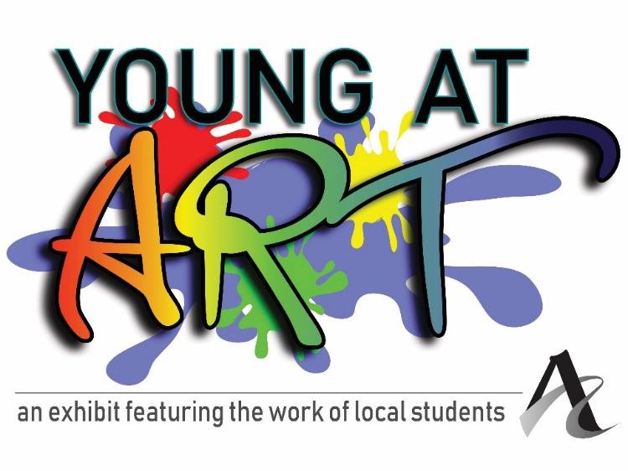
Young at Art, the Arts Council’s annual youth art exhibit, gives local young artists in grades K-8 the opportunity to display artwork in a professional gallery setting.

Each artist (grades K-8th) is allowed one 2D piece, or one 3D piece.
Work can be dropped off at 212 Main Street during the following times:
April 9th through 12th, from 10 am – 4 pm.

Teachers can submit up to ten 2D pieces and/or ten 3D pieces per school.
Teachers: please email andrea.adams@artswin.org to make arrangements if you need help getting student artwork downtown.

Calendar:
Exhibit dates:
April 23rd through May 10th

Artists Reception:
Saturday, April 27th
Noon – 1:30 p.m.

Open to all students in grades:
Kindergarten – 8th in any school district
Homeschoolers are welcome!

Drop artwork off at:
212 Main
Evansville, IN
April 9th through 12th from 10 a.m. – 4 p.m.

Artwork pick up:
May 14th – 17th
10 a.m. – 4 p.m.

Next Steps: Fill out the registration form and turn it in with your student’s artwork during the drop off days and times at the Arts Council (212 Main Street in downtown Evansville). Make sure the artwork is labeled on the front of the piece with the student’s name, grade, and school (and title, media, and price if so desired). Then come celebrate the young artists during the casual open house reception on Saturday, April 27th from noon – 2 pm!

IMPORTANT: Every piece must be tagged on the front with Students Name, Grade, School. If there is a title and price, you may also include it.

Student’s Name: ____________________________________________________________

Title of Artwork: ______________________________________________________________

Medium: ____________________________________________________________________

School (or “Homeschooled”): ________________________________________________

Grade: _____________________

Parent or teacher’s email address: ___________________________________________

Parent or teacher’s phone number: __________________________________________

Important: All work should be clearly labeled with the student’s name on the front of the piece. Work that is unmatted or unframed may be pinned in the four corners or adhesive may be used on the back of the piece, which may result in permanent marks on the corners or the back of the piece.

If your student would like to sell their work in this exhibit, they may add a price. The Arts Council takes a 35% commission on all sales, which goes right back into our programming. There is a process for artists getting their share of sales, which usually takes about 3-4 weeks.

Price, if for sale: ________________

If the piece sells, to whom should the check be made out?

______________________________________________________

• Hold Harmless Agreement: Submission of this application and the piece(s) represented, shall constitute an agreement on the part of the artist to comply with the conditions set forth in this prospectus, including the following: I hereby release and discharge The Arts Council of Southwestern Indiana staff and board from any and all claims occasioned by damage or loss of art while in the possession of The Arts Council of Southwestern Indiana. No work accepted for the exhibition may be withdrawn prior to the close of the exhibition. Permission to reproduce the work for publicity, documentary or educational purposes is hereby granted.

Parent Signature Date

